## **Win Merge**

## **Pre-requisites:**

* User must have executed Item No. 1.
* WinRM service should be enable on Target machine.
* WinRM port 5985 and 5986 should be open in Target machine's OS and firewall as well.
* Port 80 and 443 should be open in Target machine's OS and firewall as well.
* Open Google Chrome.
* You can Directly download the chrome by hitting below usrl.

<https://winmerge.org/downloads/?lang=en>

Note: - After hitting the URL, you will get the option "WinMerge-2.16.18-x64-Setup.exe" just click on that and the downloading will start.

Steps: Follow the below steps to copy WinMerge:

* 1. Log in to the machine where WinMerge will be copy.
* 2. Go to the location where 'WinMerge-2.16.18-x64-Setup.exe' setup file is downloaded.
* 3. Copy the 'WinMerge-2.16.18-x64-Setup.exe' setup file.
* 4. Navigate to the specific directory where 'WinMerge-2.16.18-x64-Setup.exe' will be copied. (C:\Share\win_merge)
* 5. Paste the copied 'WinMerge-2.16.18-x64-Setup.exe' setup 'file.

## **Installation:**

Steps: Follow the below steps to install Win Merge:

1. Navigate to the directory where WinMerge-2.16.18-x64-Setup.exe file is copied.

2. run as an administrator.

3. Double click on ''WinMerge-2.16.18-x64-Setup.exe". After that 'Welcome to the Win Merge Setup Wizard' will be opened.

4. License Agreement wizard will open Click on 'next' button.

5. Select the location where Win Merge will install and Click on 'next' button.

6. select components which will be install and Click on 'next' button

7. Select Start menu folder and Click on 'next' button.

8. select additional task and Click on 'next' button.

9. Ready to Install, now Click on 'Install' button.

10. After Installation button, click on 'Finish' button. (Note: - Follow the on-screen Instruction and finish the installation.)

Now Win Merge has been successfully installed.

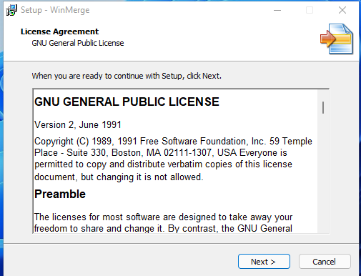

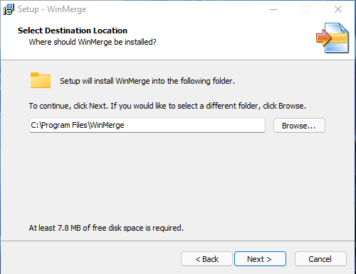

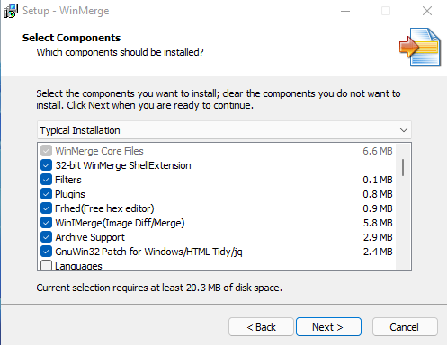

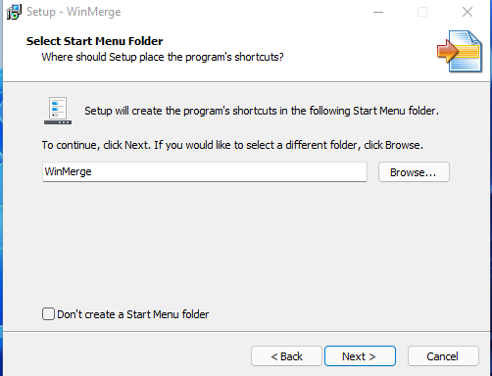

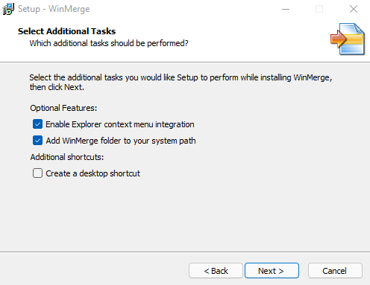

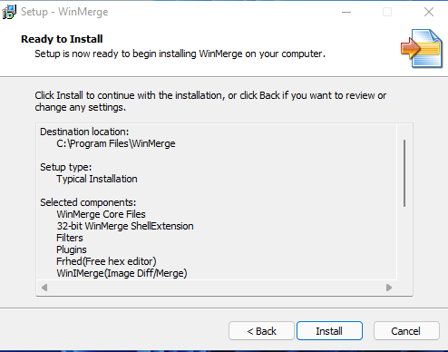

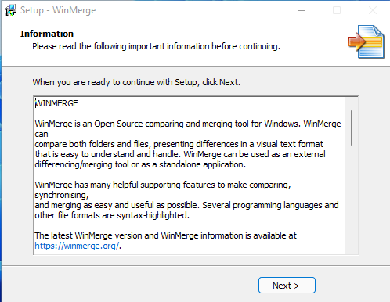

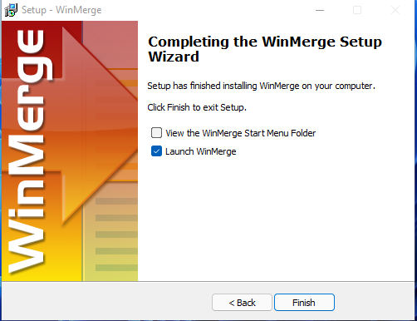

## **Verification:**

* Open 'Control Panel'.
* Navigate to 'Programs\Programs and Features'.
* ‘WinMerge 2.16.18.0 x64’ must be present in the installed software list.

